TEXT about INAZIO URRUTIA

- Website

www.aitu.es

www.inaziourrutia.com

- Section in ARTS CAD

http://josegalvan.artscad.com/A55A04/A3.nsf/BlogByCategory?OpenView&RestrictToCategory=Espa%F1a-Artistas

- Biography of Inazio Urrutia

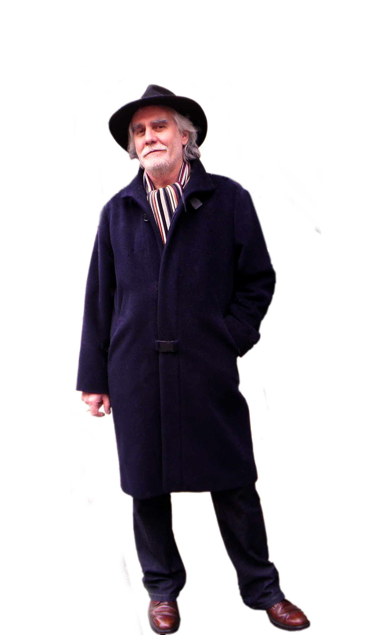
Inazio Urrutia was born in Bilbao (Vizcaya) in 1948. He undertook his studies in architecture, construction engineering and building quality surveillance in several Spanish major cities. After completing his studies, he continued to improve and develop his knowledge in these fields –some in an individual manner and some working together with professionals from the architecture and engineering domains. It is during these years where he applies his background and improves his knowledge in art from a holistic point of view.
His academic background in architecture and construction engineering along with his artistic sense, allows him to combine a free vision –almost anarchic- full of knowledge on materials, their behaviours, calculations and alloys, etc. thanks to his background in construction engineering and, on the other hand, a rational approach to order, composition, balance and aesthetics offered by the clarity of architecture.
His work of this artist interlinks the interior of the human being, his beliefs, his childhood memories, the atavistic fears we carry within in the search of new forms. In order to carry this out successfully, he focus’ on daily life objects. More often he concentrates on the objects that have become clearly invisible to our eyes in our every day routines. Curiosity along with conferring to his work a sense/beauty throughout a severe and meticulous PROCESS is the conductive wire of his creativity –sometimes being extremely intense or idle while reflexive periods contribute also to this process. Other creative path he takes includes leaving his work to rest for periods of time before resuming with it. This process is the engine of his talent and is a part of himself as well as the subconscious influences from his native land. The Basque Country, the Bilbao river, the sea with its ports and breakwaters, the traditional Basque sports –the Ox competition, the Basque ball, the ezkolari... these are the cores of the concepts as the discussion about the existence of a Basque art with its distinctive characteristics is quoted any time the Basque sculpture comes into scene.
The brand AITU. ARTE Y DISEÑO offers its customers all sorts of designs, sculptures, Paintings, Christmas Items and also, jewellery, costume jewellery, textile, accessories, watchmaking, household items, perfumery, miscellaneous and many others. This makes his production a 'constant search for new and different forms of expression' throughout art.
This author has great preoccupations, which push him to investigate the materials he works with, forms, textures, colours... all of them being a part of his research. For him, even the slightest object holds 'certain beauty within', and he always finds the way to take that beauty out and conjugate it in a simple, functional and aesthetic manner. 'Art is not confronted with what seems to us an everyday life item' he quoted. This is the underlying philosophy that grants his artworks a hale and fresh air combined with imagination, freed from schedules and duties.
He enjoys his time giving life to his creations, for which the final result is not important, but the process of creation and development. Taking into concern the environment, he understands the recycling process as a new life for wasted items that can easily become furniture, accessories, art... He manages to transform these into beauty, letting the item guide his imagination. His drawings and sketches for his artworks are precious to him, they are 'his sons' -the sons he creates, he models, in which he spends time and space. All this in a way that, once they are done, those sons would have attained their age of maturity.

- Social Networks:
Facebook: www.facebook.com/AITU.ArteyDiseno
Twitter: www.twitter.com/InazioUrrutia
G+:www.plus.google.com/u/0/b/104159162877712559118/104159162877712559118/posts
Pinterest: www.pinterest.com/aituarteydiseno
LinkedIn: www.linkedin.com/in/inaziourrutia
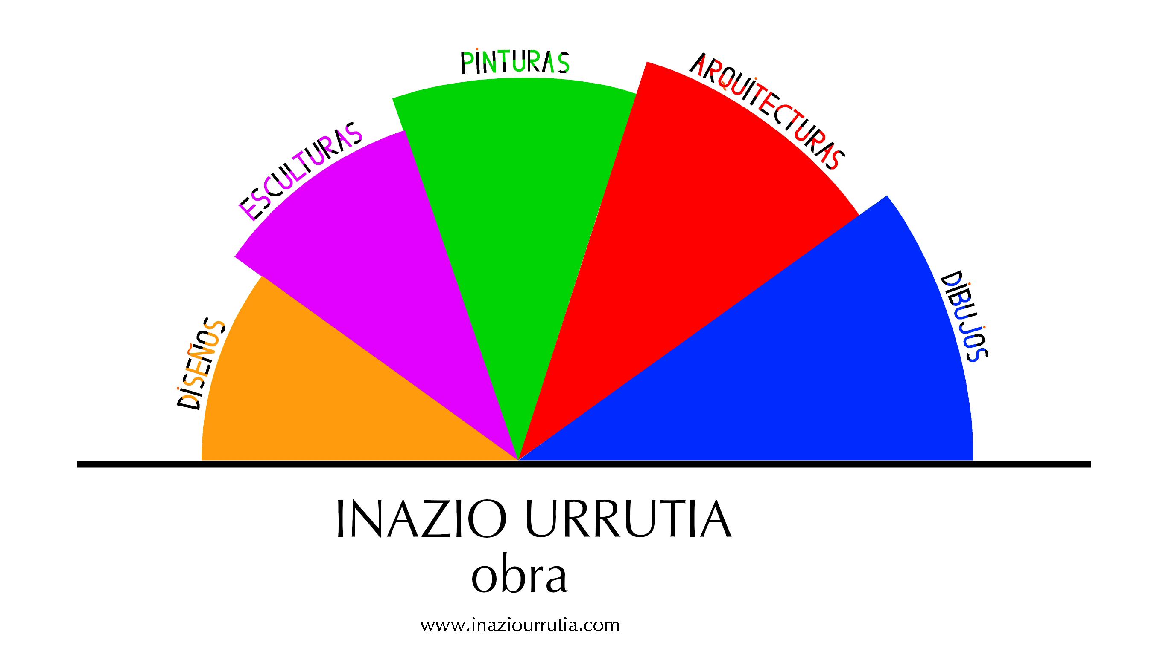
- OTHER PHOTOS



